**Assignment**

**NAME-PANKAJ SATI**

**COURSE-MCA-3A**

**STUDENT ID-20711048**

**1. Write a program to use the mathematical operators.**

**Code:-**

num1, num2=input("enter the two numbers:").split()  
print((int(num1)+ int(num2)))  
print((int(num1)- int(num2)))  
print((int(num1)/ int(num2)))  
print((int(num1)* int(num2)))  
print((int(num1)% int(num2)))  
print((int(num1)** int(num2)))  
print((int(num1)// int(num2)))

**Output:-**

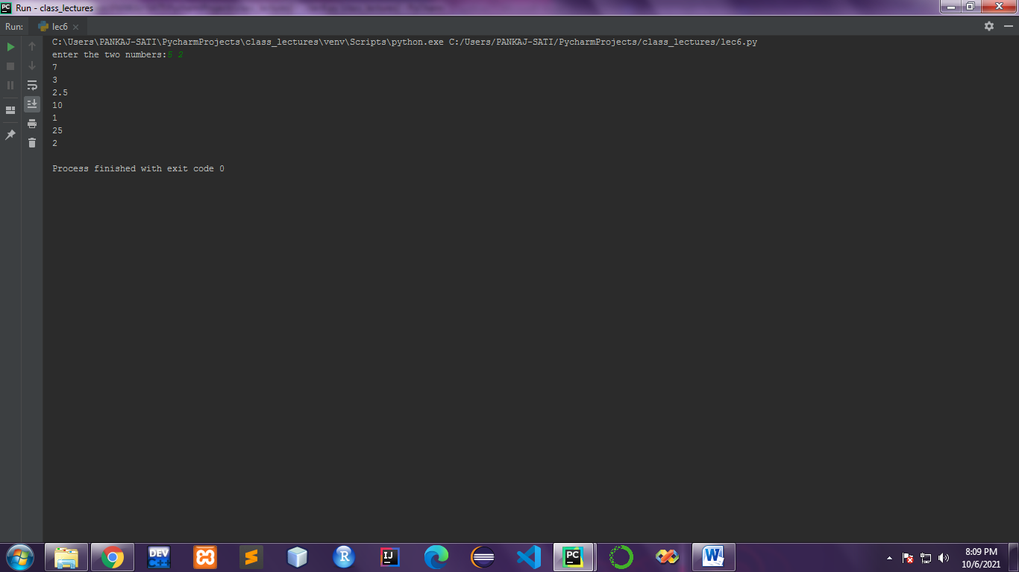

**2.write a program to take an input of numbers from the user and print the Fibonacci series to the terminal number.**

**Code:-**

n = int(input("Enter the value of 'n': "))  
a = 0  
b = 1  
sum = 0  
count = 1  
print("Fibonacci Series: ", end = " ")  
while(count <= n):  
 print(sum, end = " ")  
 count += 1  
 a = b  
 b = sum  
 sum = a + b

**Output:-**

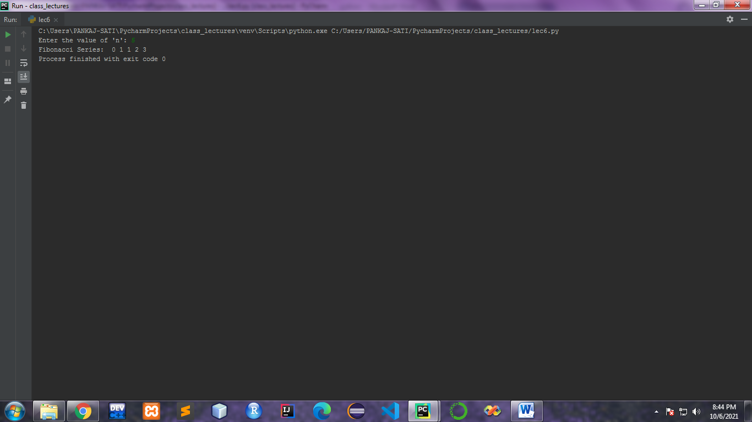

**3.Write a program to print the factorial of the number input by the user.**

**Code:-**

num =int(input("enter a number:-"))  
factorial = 1  
if num < 0:  
 print("Sorry, factorial does not exist for negative numbers")  
elif num == 0:  
 print("The factorial of 0 is 1")  
else:  
 for i in range(1,num + 1):  
 factorial = factorial*i  
 print("The factorial of",num,"is",factorial)

**Output:-**

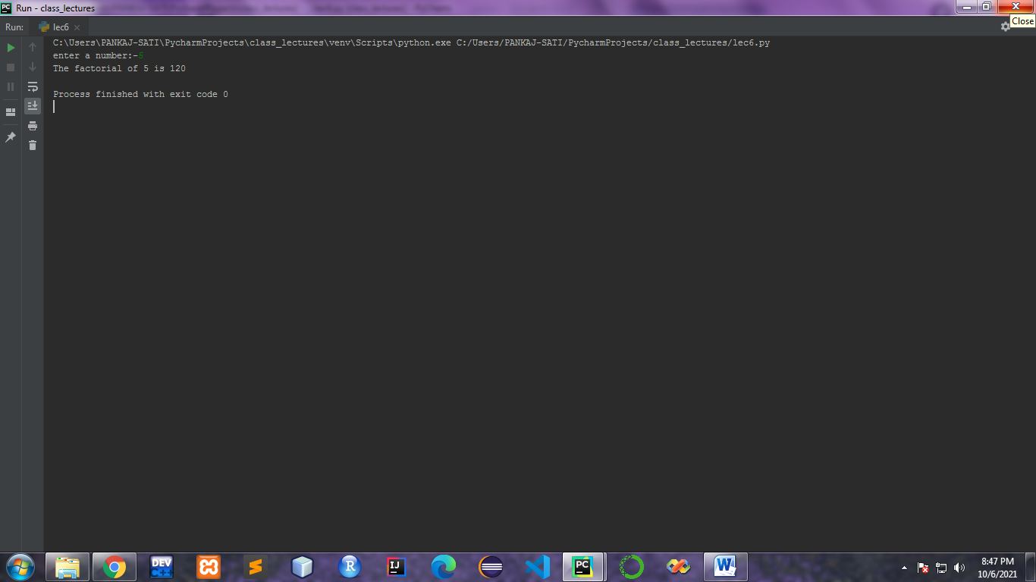

**4. Write a program to check whether a given number is a prime number or not using loops.**

**Code:-**

num = int(input("enter a number;-"))  
if num > 1:  
 # check for factors  
 for i in range(2, num):  
 if (num % i) == 0:  
 print(num, "is not a prime number")  
 print(i, "times", num // i, "is", num)  
 break  
 else:  
 print(num, "is a prime number")  
else:  
 print(num, "is not a prime number")

**Output:-**

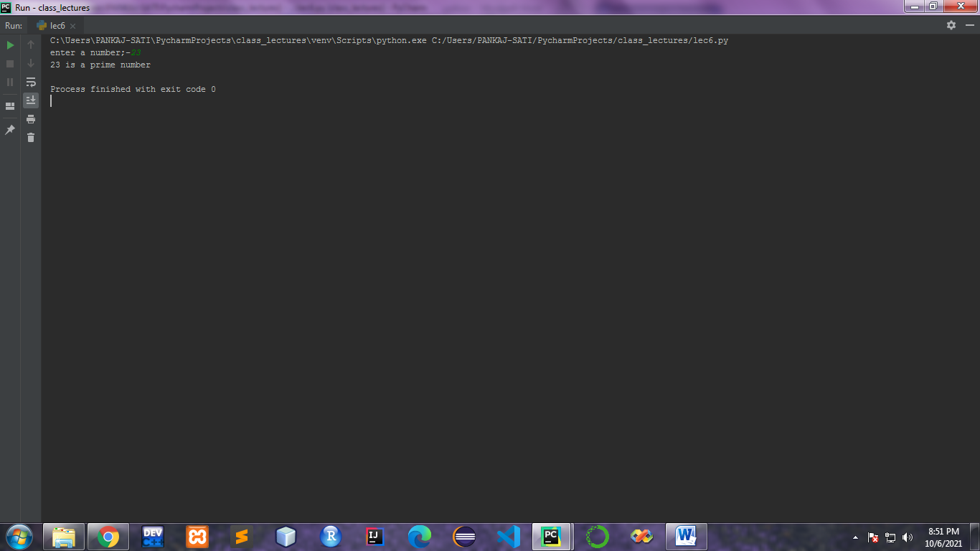

**5.Write a program to demonstrate the importing of modules of python.**

**Code:-**

from math import pi  
print(pi)

**Output:-**

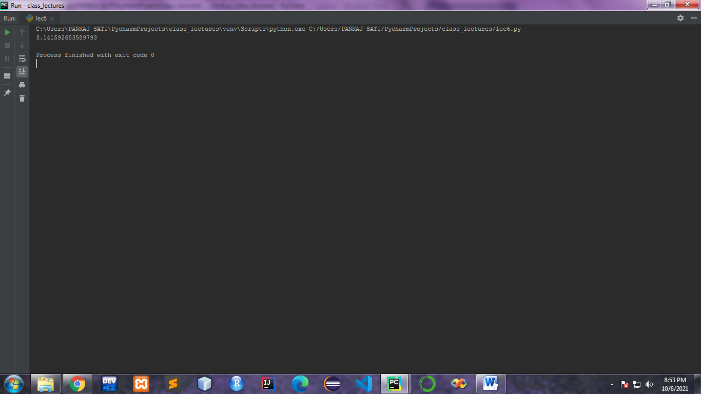

**6. Write a program to demonstrate the use of nested if statements.**

**Code:-**

num =int(input("enter a number:-"))  
if num >= 0:  
 if num == 0:  
 print("Zero")  
 else:  
 print("Positive number")  
else:  
 print("Negative number")

**Output:-**

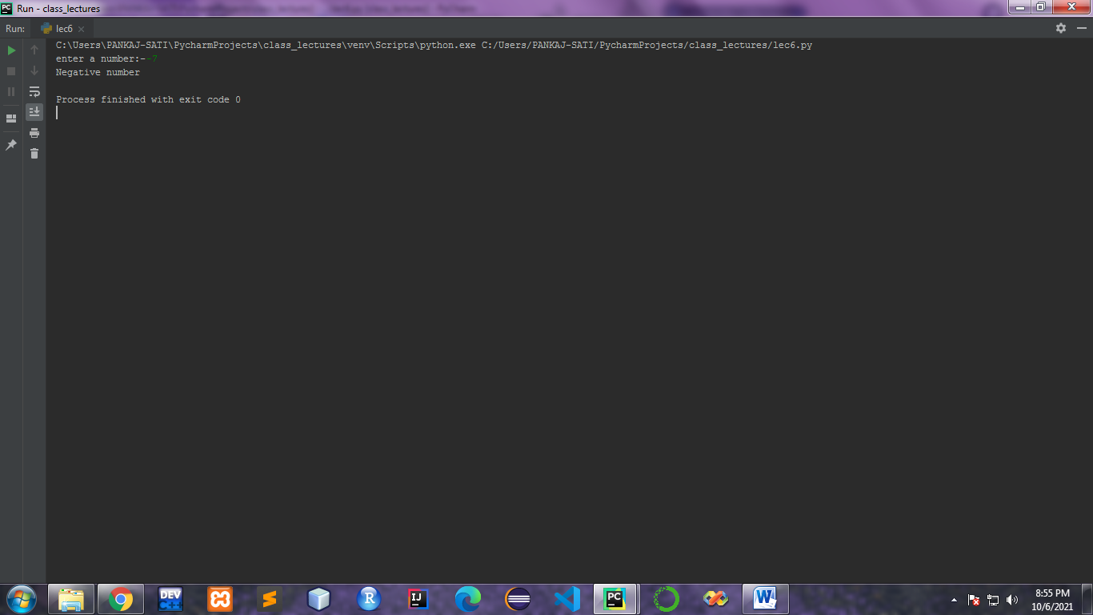

**7. Write a program to demonstrate the use of the else clause.**

**Code:-**

num =int(input("enter a number:-"))  
if num >0:  
  
 print("Positive number")  
else:  
 print("Negative number")

**Output:-**

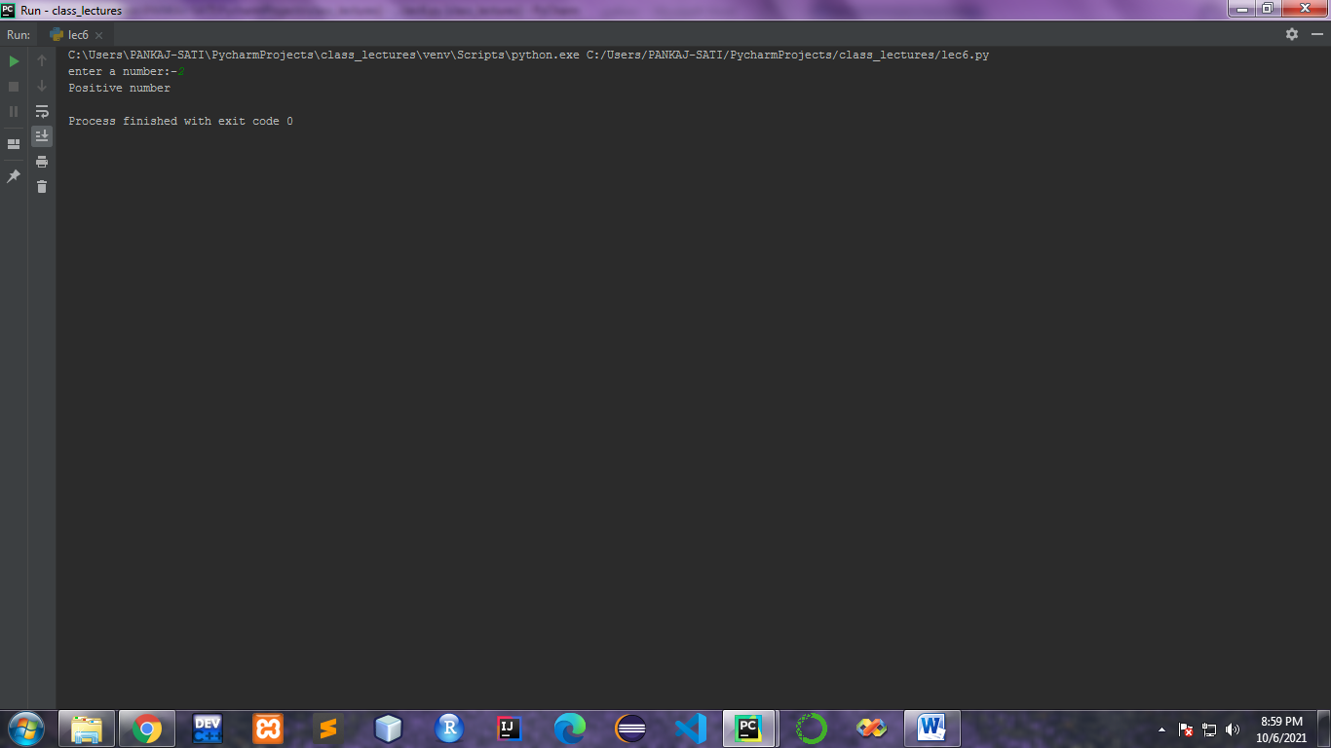

**8. Write a program to illustrate the usage of Tuples.**

**Code:-**

thistuple = ("apple", "banana", "cherry")  
print(thistuple)

**Output:-**

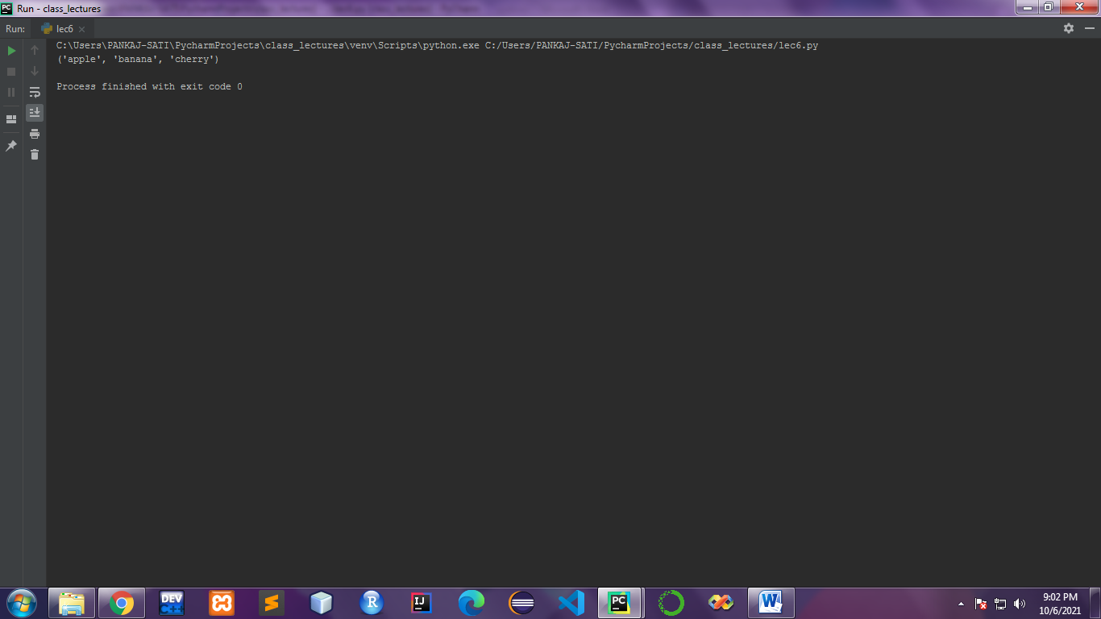

**9.Write a program for searching an element and sorting a List.**

**Code:-**

my_list = [3, 2, 1]  
my_list.sort()  
print(my_list)  
n=int(input("enter the element to be searched:-"))  
print("element found at index:-",my_list.index(n))

**Output:-**

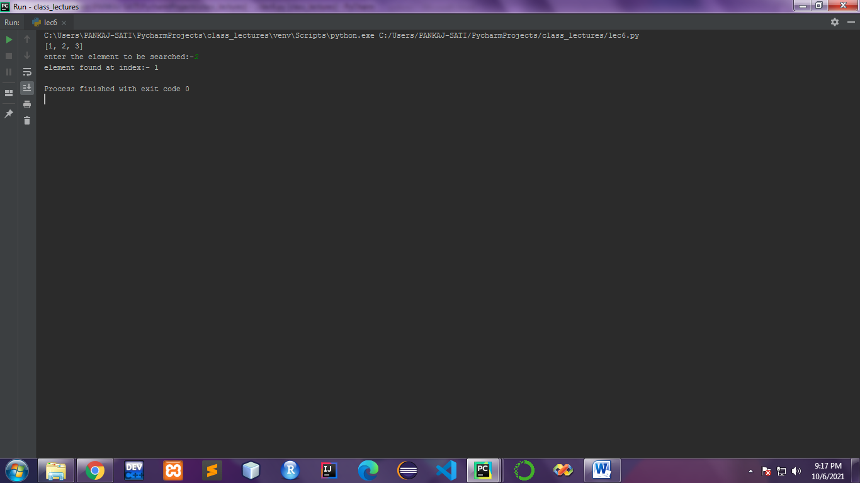

**10. Write a program to illustrate the usage of Dictionaries.**

**Code:-**

2={"pankaj":"burger","rahul":"chowmein","pari":"momos","chetan":{"breakfast":"maggi","lunch":"dal chawal","dinner":"pumpkin"}}  
print(d2)#dictionary key pairs  
print(d2["chetan"])  
print(d2["chetan"]["dinner"])

**Output:-**

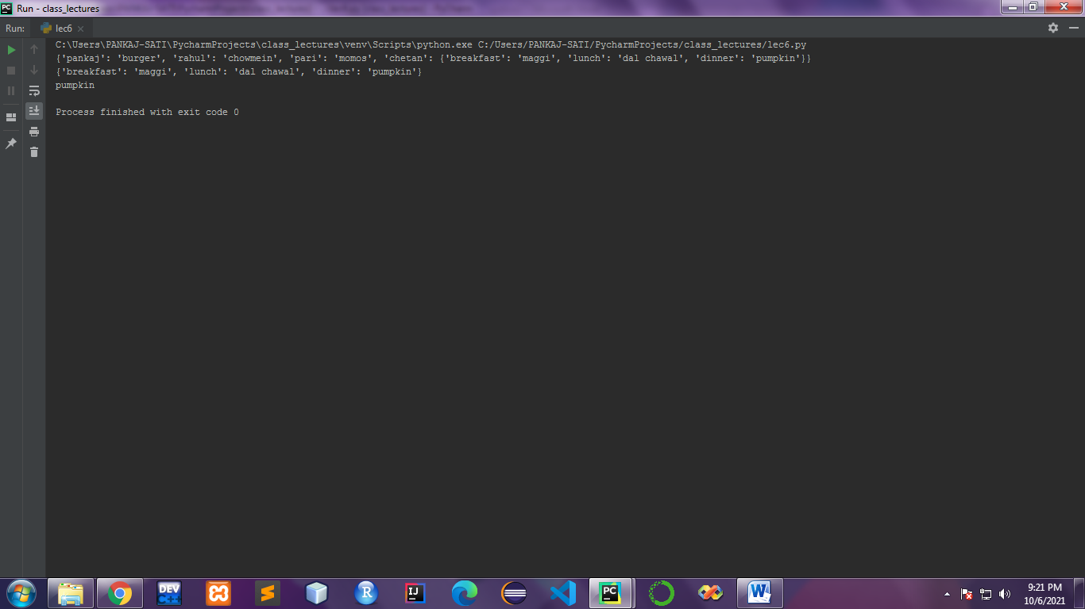

**11.Write a program to find the mean. mode and median of the given range of numbers.**

**Code:-**

import numpy  
from scipy import stats  
speed = [99,86,87,88,111,86,103,87,94,78,77,85,86]  
x = numpy.mean(speed)  
x1 = numpy.median(speed)  
x2 = stats.mode(speed)  
print("Mean=",x)  
print("Median=",x)  
print(x2)

**Output:-**

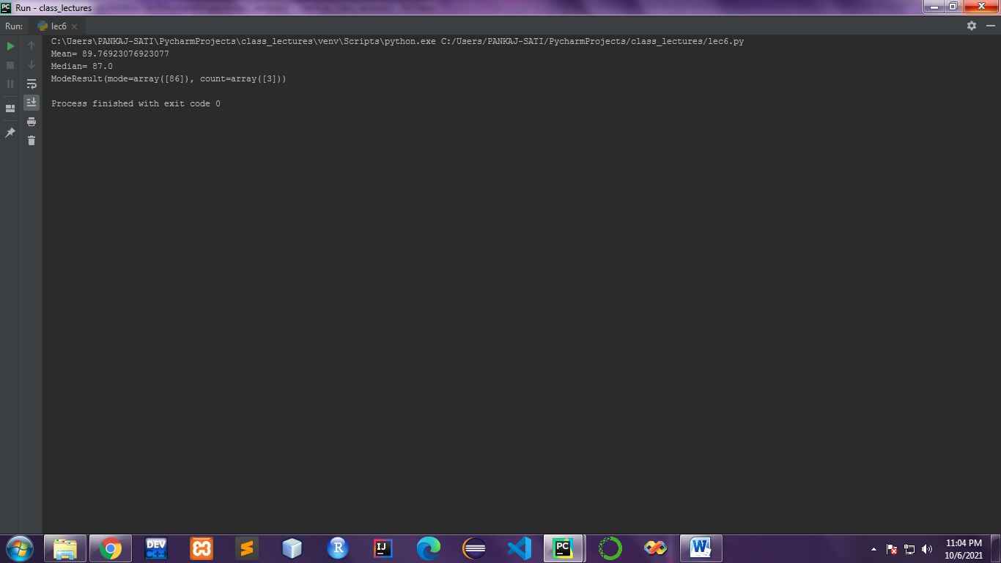

**12 Write a program to calculate the standard deviation of a given set of numbers.**

**Code:-**

import numpy  
speed = [86,87,88,86,87,85,86]  
x = numpy.std(speed)  
print("standard deviation=",x)

**Output:-**

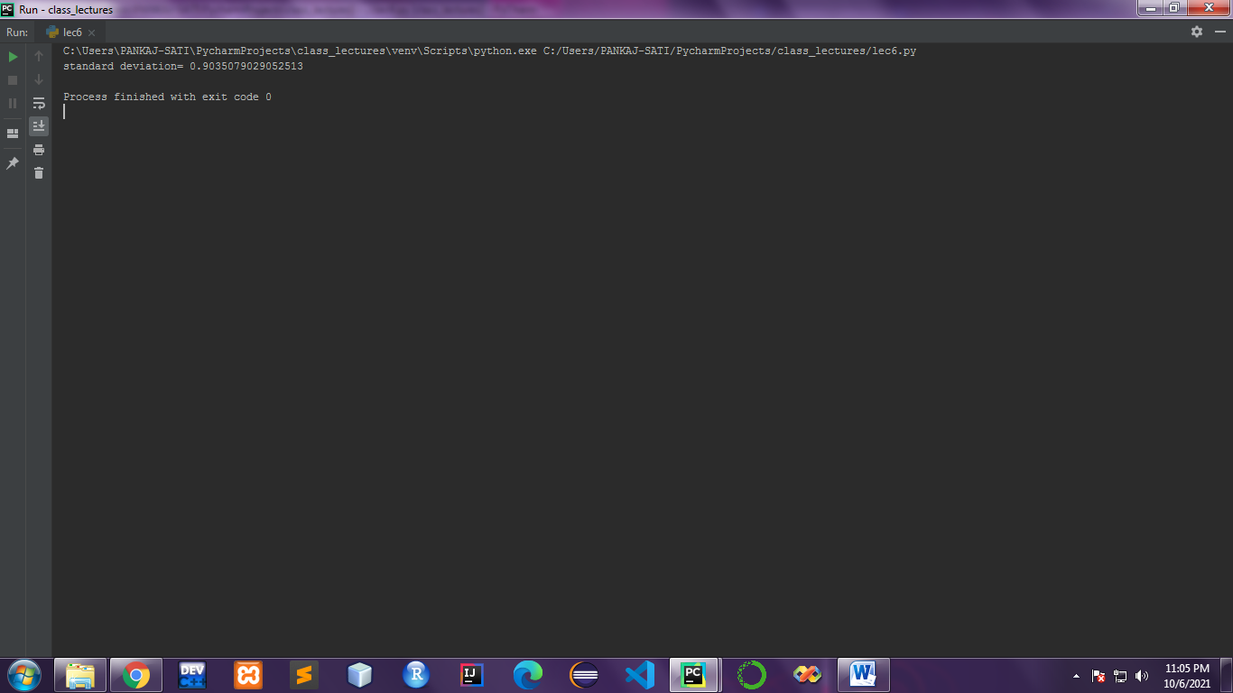

**13. Write a program to calculate the addition of two 3x 3 matrices.**

**Code:-**

X = [[12,7,3],  
 [4 ,5,6],  
 [7 ,8,9]]  
  
Y = [[5,8,1],  
 [6,7,3],  
 [4,5,9]]  
  
result = [[0,0,0],  
 [0,0,0],  
 [0,0,0]]  
  
for i in range(len(X)):  
  
 for j in range(len(X[0])):  
 result[i][j] = X[i][j] + Y[i][j]  
  
for r in result:  
 print(r)

**Output:-**

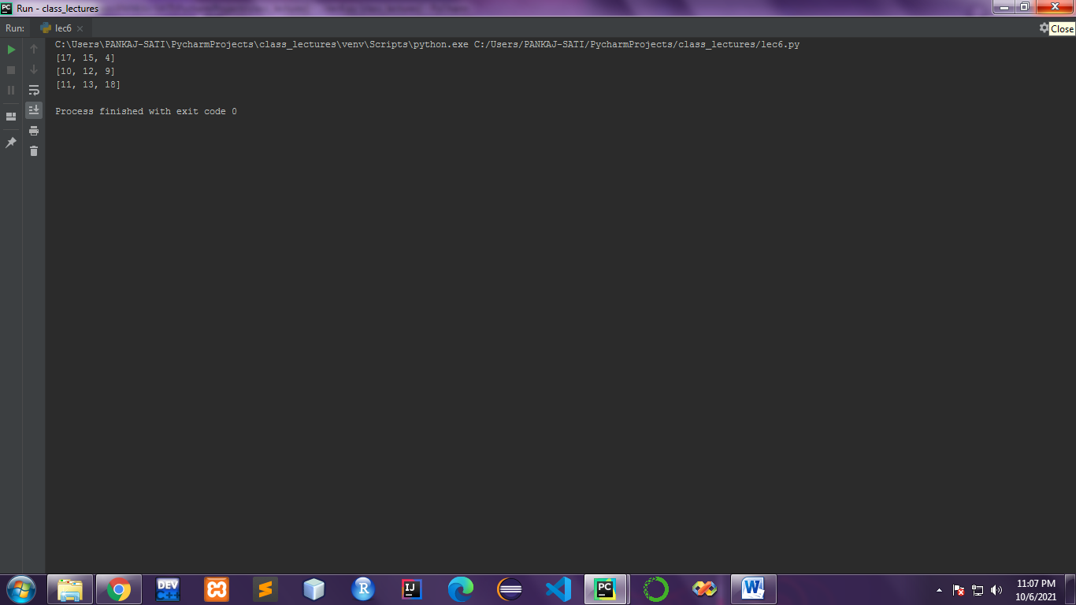

**14. Write a program to calculate the multiplication of two 3x 3 matrices.**

**Code:-**

X = [[12,7,3],  
 [4 ,5,6],  
 [7 ,8,9]]  
  
Y = [[5,8,1,2],  
 [6,7,3,0],  
 [4,5,9,1]]  
# result is 3x4  
result = [[0,0,0,0],  
 [0,0,0,0],  
 [0,0,0,0]]  
  
  
for i in range(len(X)):  
  
 for j in range(len(Y[0])):  
   
 for k in range(len(Y)):  
 result[i][j] += X[i][k] * Y[k][j]  
  
for r in result:  
 print(r)

**Output:-**

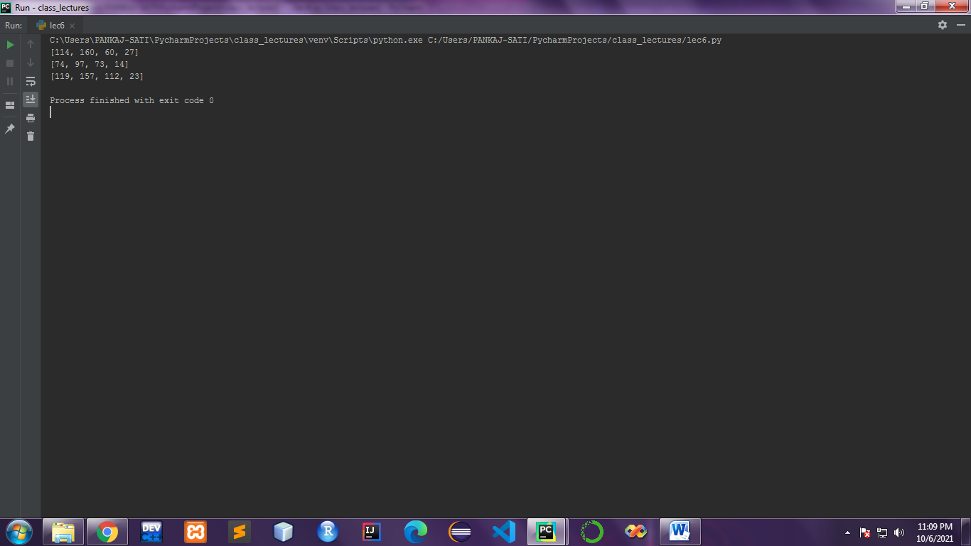

**15. Write a program to calculate the inverse of the given matrix.**

**Code:-**

import numpy as np  
A = np.array([[6, 1, 1, 3],  
 [4, -2, 5, 1],  
 [2, 8, 7, 6],  
 [3, 1, 9, 7]])  
  
# Calculating the inverse of the matrix  
print(np.linalg.inv(A))

**Output:-**

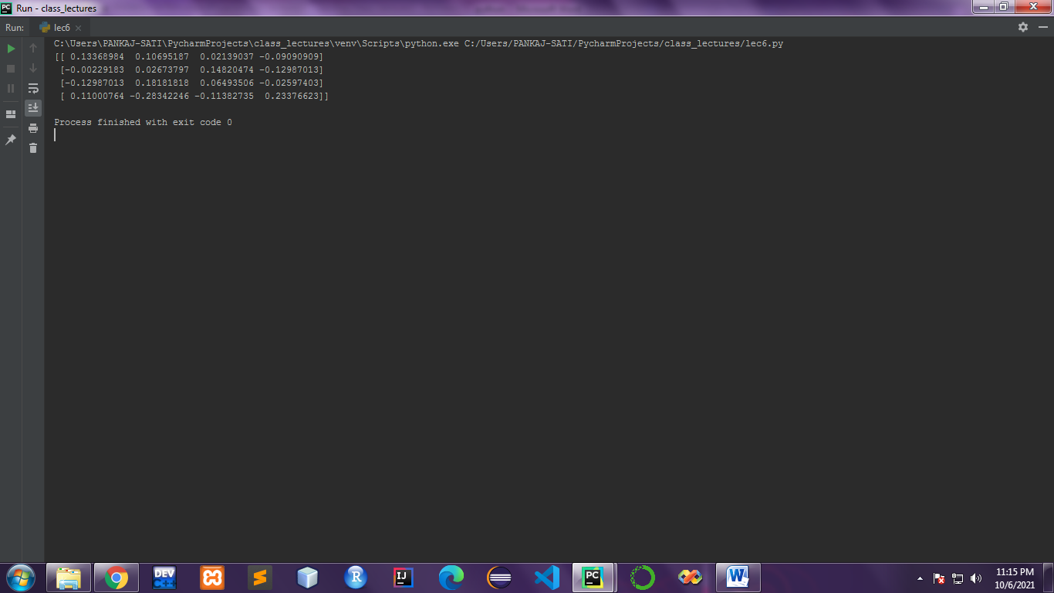

**16. Write a program to calculate the transpose of the given matrix.**

**Code:-**

X = [[12,7],  
 [4 ,5],  
 [3 ,8]]  
result = [[0,0,0],  
 [0,0,0]]  
for i in range(len(X)):  
   
 for j in range(len(X[0])):  
 result[j][i] = X[i][j]  
  
for r in result:  
 print(r)

**Output:-**

